Good deeds: an interview with Laura Marks
Laura Marks MBE is the founder of Mitzvah Day, an annual social action event based on the Jewish concept of mitzvah — a good deed. In November 2024 Cambridge PhD student Peach interviewed Laura to learn more about Mitzvah Day and its significance for interfaith work.
Watch a short extract from the interview (1 min 50; via YouTube.com).
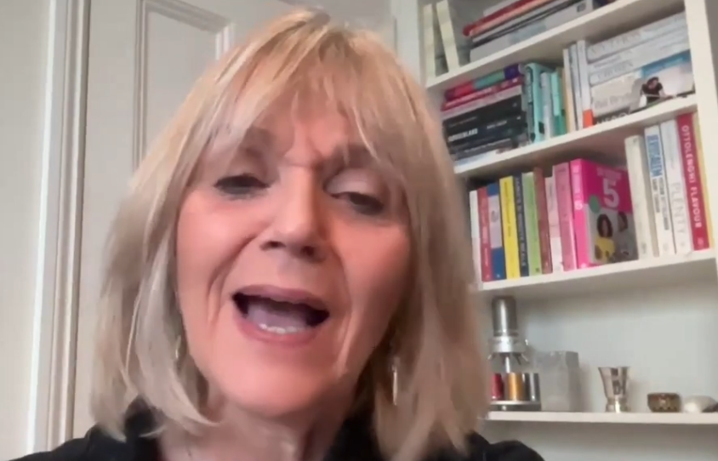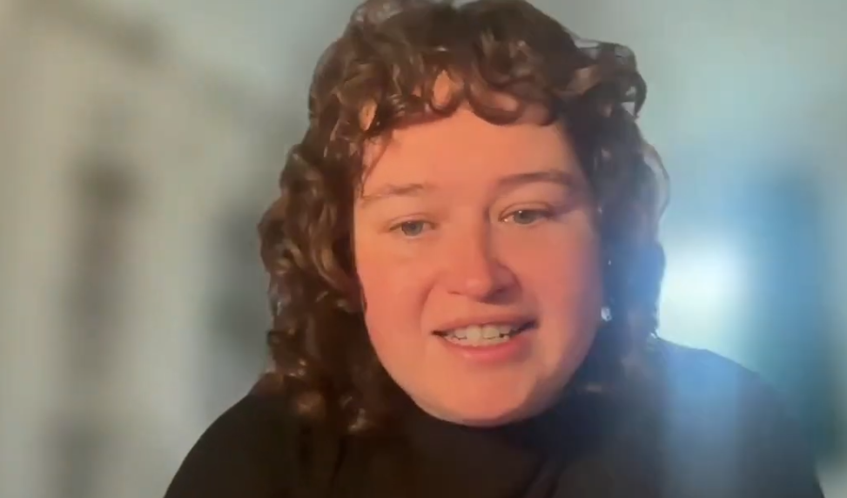
(A transcript for the extract is provided as an appendix to this resource.)

Discussion prompts
- What examples of good deeds does Laura give? What other actions do you think might be suitable for someone planning to celebrate Mitzvah Day?
- Laura explains that Mitzvah Day has become a “Jewish-led model of interfaith”. Why might working together across faiths be more powerful than working alone?
- Laura offers two translations of the Hebrew word mitzvah: “commandment” and “good deed”. What is the effect of these two different terms?
- Both refer to the practical (what you must/should do). Is this similar or different to what seems important among other faith and belief communities?

Writing prompts
- Imagine you are planning a Mitzvah Day activity in your school. Write a letter inviting students from different faith backgrounds to join. What would you say to encourage them?
- Write a diary entry from the perspective of a student who took part in an interfaith service project. What did they learn? How did it feel to work with people from different backgrounds?

Classroom activity
Create a visual map of your local area showing places of worship, charities, and community centres. Discuss how these groups could work together on a shared project.

Additional resources

Birthing Mitzvah Day and women-led interfaith movements
The original interview (~16 minutes) includes discussion about two organisations Laura co-founded since setting up Mitzvah Day: Nisa Nashim and the Women’s Faiths Forum. Contrasting with Mitzvah Day, these organisations were set up as intentional interfaith endeavours.
Watch the interview (with captions) on YouTube: https://youtu.be/MaspS8FdPtU
Or listen to Peach and Laura via captivate.fm: Birthing Mitzvah Day and women-led interfaith movements - Religion and Global Challenges

Mitzvah Day 2025: Building Bridges
This year Mitzvah Day will take place on Saturday 23 November, shortly after the end of UK Inter Faith Week. The theme celebrates 20 years of Building Bridges. Laura explains:
“This year, we ask all those taking part to connect with local charities and other faith communities who may still be strangers. We can break down barriers through meaningful, side-by-side projects that offer real support where it matters most.”
(Source: JewishNews.co.uk, 19 June 2025.)
More information about the history of Mitzvah Day and its activities is available on the dedicated website: www.mitzvahday.org.uk

More on Community and service
Flora Samuel is an architect. Much of her work explores how people can get involved in decisions about the place where they live. Interviewed last year, she said: “faith groups are some of the most important bits of social glue that we have. I’m really interested in how faith groups contribute to the making of community... And I’m really interested in the culture of care that runs through faith groups.” | Watch Flora’s interview on YouTube. | Listen to the full interview, Faith in urban spaces (via captivate.fm).
Jagbir Jhutti-Johal is a researcher and activist. Her expertise includes knowledge of the British Sikh community as well as interfaith work. In an interview with Peach she explained what motivates her to advocate for others: “it’s the Sikh concept of Sarbat Da Bhala, the welfare of all, that really sticks in my mind, and I'm like always thinking, okay, what am I doing? How am I going to ensure that the wellbeing of everyone within society is protected?” | Watch Jagbir on YouTube. | Listen to Jagbir on advocacy and mentorship (via captivate.fm).
Sriya Iyer is an economist. Interviewed by Ryan, a church leader in north Cyprus, she pointed to the many different ways that faith communities get involved in improving people’s lives. Different faiths might have competing beliefs about what matters most, but they are good at cooperating to improve society.
Watch an extract from Sriya & Ryan’s conversation on YouTube. | Listen to Sriya’s full interview on captivate.fm.
Also in Interfaith Futures:
- Chris Baker points out how faith communities excel at showing solidarity in times of crisis. This shows the potential to “create responses to really deep-seated issues in our society, like food poverty, racism, [and] climate change”. Listen as Chris and Reem discuss some radical possibilities (via captivate.fm).
- Economist Michael Pollitt illustrates how faith communities have come together to effect change—to improve civil rights and to abolish apartheid and debt. He hopes the same can happen in response to climate change. Hear Michael and Noah discuss collective power (via captivate.fm).
- Michael Wakelin discusses how the Religion Media Centre has been helping strengthen connections between faith communities and local media networks. Hear Michael in conversation with Susie about his work connecting communities (via captivate.fm).
- Arezoo Farahzad discusses Baha’I perspectives on religion and community and the benefits of the International dinner she has established in Plymouth. Listen to Arezoo and Julia chat about food, faith and love (via captivate.fm).

Related activity
Peach researches women’s engagement in interfaith spaces and will be part of the panel at Cambridge’s Food & Faith webinar.

Transcript (of short interview)
The short video is condensed from the original. Here is a transcript:
Peach: ...you’re responsible for Mitzvah Day, which is taking place for the 20th time later this month. So I wondered kind of what was your vision when you started out and how has evolved? And does this tell us anything about how the sort of general interfaith landscape has changed?
Laura: The cause that I got into, the cause that Mitzvah Day is all about is enabling other people to do things that they are passionate about.
So Mitzvah Day, Mitzvah literally means a commandment, but it’s used to mean a good deed.
So Mitzvah Day is a day of good deeds.
One day, you really celebrate the good that people can do hands on.
And it very quickly became a day when Jewish people, it was set up to be Jewish, but it was always set up to be a day that Jewish people could reach out to other people. So whether we were reaching out to a local non-Jewish charity, whether we were reaching out to a mosque or a gurdwara or a church and saying, come and do it with us, the opportunities to do things hands on are there right across the board.
So whether you are cleaning up a park, you're filling a food bank, you are going and visiting old people, which is actually my favourite activity on Mitzvah Day, whatever it is, you can do something to make the world better physically.
Go out, do something and do it with other people.
So the doing it with other people is integral to Mitzvah Day.
It’s about being positive, reaching out to our neighbours, giving back and being part of a giving society, which we really need right now.
So that was my sort of start point into the interfaith world.
And I know now when I look at it, it’s a Jewish-led model of interfaith.

